

**Tribhuvan University**

**Faculty of Humanities and Social Sciences**

**ONLINE HOTEL MANAGEMENT SYSTEM**

**A PROJECT REPORT**

**Submitted to**

**Department of Computer Application**

**SUNGAVA COLLEGE**

Khairahani-6, Chitwan

***In partial fulfillment of the requirements for the Bachelors in Computer Application***

**Submitted by:**

NAME: GARIMA DHITAL NAME: MIRA KHADKA

ROLL NUMBER:13 ROLL NUMBER:20

Under the Supervision of

**BISHWO PRAKASH POKHREL**

Date:



**Tribhuvan University**

**Faculty of Humanities and Social Sciences**

**SUNGAVA COLLEGE**

**Supervisor’s Recommendation**

I hereby recommend that this project prepared under my supervision by GARIMA DHITAL and MIRA KHADKA entitled “**ONLINE HOTEL MANAGEMENT SYSTEM”** in partial fulfillment of the requirements for the degree of Bachelor of Computer Application is recommended for the final evaluation.

**SIGNATURE OF SUPERVISOR**

BISHWO PRAKASH POKHREL

HEAD OF DEPARTMENT

BCA DEPARTMENT

KHAIRAHANI 8, CHITWAN



**Tribhuvan University**

**Faculty of Humanities and Social Sciences**

**SUNGAVA COLLEGE**

**LETTER OF APPROVAL**

This is to certify that this project prepared by GARIMA DHITAL and MIRA KHADKA entitled “**ONLINE HOTEL MANAGEMENT SYSTEM”** in partial fulfillment of the requirements for the degree of Bachelor in Computer Application has been evaluated. In our opinion it is satisfactory in the scope and quality as a project for the required degree.

|  |  |
| --- | --- |
| **BISHWO PRAKASH POKHREL**  **Supervisor**  BCA DEPARTMENT, SUNGAVA COLLEGE  KHAIRAHANI 8, CHITWAN | BISHWO PRAKASH POKHREL  **Coordinator**  BCA DEPARTMENT  KHAIRAHANI 8, CHITWAN |
| **Internal Examiner** | **External Examiner** |

**Abstract**

This project examines the aspect of the hospitality industry which is Hotel management. In the 21st century the use of the internet, computers and other electronic devices have made handling different jobs and aspects of management very easy. This project is the design and implementation of an electronic hotel management system that provides proper management of data transactions in a centralized and organized manner and also provides a user friendly interface with which the user can interact easily with the just little or elementary knowledge of operating computers. This project is designed to create a platform that allows both the user and administrator to keep the track of transactions like room reservations, room booking, administration of the hotel, record keeping, online reservation and other day to day activities involved in the running and management of a hotel. The implementation is based on the requirements for the hotel management system. The project work is divided into five major categories which are: Front desk, Accommodation, Catering, finance & Account and Guest’s Record. This project accomplished the task of building a system that ensures accurate record maintenance which was done through proper identification of customers and the proper designation of the user functions with the most of the processing being done automatically. An electronic hotel system information system is required to assist management of data in the hospitality industry and also make the entire hotel management process easier. The project was designed with the use of Microsoft visual studio which is an integrated development environment made by Microsoft. It can be used to develop console and graphical user interface applications along with windows form applications websites. The database system was created using the Microsoft SQL server (MSSQL).

**Acknowledgement**

We are thankful to our respected project Guide Bishwo Prakash Pokherel for his persistence help throughout completion of this project. His suggestions and guidance in every stage is one of the major reasons of successful completion of my project. Without his proper guidance our project would not has been accomplished on time.

We would like to express our sincere thankfulness to Mr. Bishwo Prakash Pokharel, Co-Ordinator, BCA program, Sungava College, for encouraging us to develop this software. During the pre-development stage, developing state and post-developing stage, he always remained the source of inspiration and encouragement for us to complete this project in time.

A bit closer to our home, we would like to add my heartfelt appreciation for our parents for their infinite kindness and patience throughout our academic career.

Many thanks to Sungava College, for providing us the great platform on the field of computer education and generously providing the relevant resources. We are thankful to Mr. Sobaraj Poudel, for helping us in every aspect of the academic years in Sungava. We are also thankful to Mr. Narayan Nepal, and all staff members of the Sungava College for their kind support.

Finally, we would like to thank all of hidden concern bodies who helped us to meet my goal on this time and future too.

**Thank you!**

**Student1 Name: Garima Dhital Student2 Name: Mira Khadka**

**Signature: Signature:**

**Table of contents**

**Abstract** ......4

**Acknowledgement** 5

**List of Abbreviations** 8

**List of Figures** 9

**List of Tables** 10

**Chapter 1: Introduction** 11

**1.1 Introduction** 11

**1.2 Problem Statement** 11

**1.3 Objectives** 11

**1.4 Scope and Limitation** 12

**1.5 Report Organization** 12

**Chapter 2: Background Study and Literature Review** 13

**2.1 Background Study** 13

**2.2 Literature Review** 13

**Chapter 3: System Analysis and Design** 15

**3.1 System Analysis** 15

**3.1.1 Requirement Analysis** 16

**3.1.2 Feasibility Analysis** 17

**3.1.3 Data Modeling** 20

**3.1.4 Process Modeling** 22

**3.2 System Design** 32

**3.2.1 Architectural Design** 32

**3.2.2 Database Schema Design** 33

**3.2.3 Interface Design** 36

**3.2.4 Physical DFD** 37

**Chapter 4: Implementation and Testing** 40

**4.1 Implementation** 40

**4.1.1 Tools Used…………………………………………………………………………………………………….** ..41

**4.1.2 Implementation Details of Modules** 41

**4.2 Testing** 41

**4.2.1 Test Cases for Unit Testing** 42

**4.2.2 Test Cases for System Testing** 43

**Chapter 5: Conclusion and Future Recommendations** 46

**5.1 Lesson Learnt/Outcome** 45

**5.2 Conclusion** 45

**5.3 Future Recommendations** 46

**Appendix A** 46

**Appendix B** 46

**Bibliography** 82

# List of Abbreviations

**BBMS : Online Hotel Reservation System**

**SQL : Structured Query Language**

**List of Figures:**

Figure 1: ER diagram of Online Hotel Reservation System ………………….

Figure 2: Level 0 DFD Hotel Reservation System ……………………………

Figure 3: Data Flow Diagram Opening a New Room…………………………

Figure 4: Data Flow Diagram Check-In of A New Customer……………………

Figure 5: Data Flow Diagram Record Modification……………………………...

Figure 6: Data Flow Diagram Check-Out of Customer

Figure 7: Admin Table

Figure 8: Create Account Table

Figure 9: Feedback Table

Figure 10: Rooms Table

Figure 11: Table Slider

Figure 12: Room Booking Details Table

Figure 13: Home page

Figure 14: Admin Login

Figure 15: Admin Profile

Figure 16: User login

Figure 17: Booking Form

Figure 18: Registration Form

Figure 19: Testing of Online Hotel Reservation System

# List of Tables

**Table 1: Feasibility Analysis** 19

**Table 2: Test report bugs and solutions** 44

**Chapter 1: INTRODUCTION**

**1.1 Introduction**

Online hotel reservation system is defined as the web based project which facilitates and allows users to reserve or book hotel via internet. Online hotel reservation and management system automates hotel operations and real time management of data and records.Hotel Reservation System operates a global online hotel reservation system for business and leisure travelers. Booking a hotel online is not only fast as well as convenient but also very cheap. Nowadays, many of the hotel providers have their sites on the web, which in turn allows the users to So, the proposed computerized of an online hotel management system is set to find a more convenient, well organized, faster, reliable and accurate means of processing the current manual system of the hotel for both near and far customers.

**1.2 Problem Statement**

The problem of hotel is you can’t actually tell the availability of vacant rooms in a manual way unlike there’s the, vacancies and system that records the transactions and keep the tracks of records other information regarding it. It would be benefit the personal in the charge of transaction for it would be hassle- free and user friendly; it’s difficult for the customer to their reservations through walk in, and it’s convenient to do so via internet. It’s difficult to find location of guest files: due to the large number of guests’ files, location of guest files during checking in, updating of daily expenditures, receipt generation and checking out is extremely difficult for the hotel employees. The physical files occupy too much space of about two rooms full of storage cabinets. This occupies the hotel’s space that could have otherwise been used for income generation by the hotel.. Poorly generated records encourage omission of some important data by the employees. Such data as the guests’ luggage is omitted. This leads to security problems at the hotel such as armed robberies. Due to poor management of documents encouraged by the manual system, several cases were reported where guests complained of overcharging, charging of services not used by the guests. Due to poor communication between the departments, guests are often served with services they didn’t order. Difficulty in data analysis: the accountants usually found it difficult to analyse the guest’s data during generation of expenditure bills due to missing of some records.

**1.3** **Objectives**

The main objective of this major project is to automate the complete operations of the hotel. It is aimed to maintain thousands of records. The objectives of this purposed system are as follows:

1. To enable online booking via the internet.

2. To enable automated data entry methods.

3. Ensure efficient and reliable communication within the hotel.

4. Avoid data entry errors by use of input masks.

5. Enable easy authorized modification of data.

**1.4 Scope and Limitations**

The main scope and deliverables of the project would be to:

• Understand and prepare the quick findings of hotel and it’s rooms

• Prepare high level and detailed design specifications of the system

• Prepare Test Plan & Test cases

• Develop the system and coding

• Perform unit testing and integration testing

The limitation of the project would be:

* It need internet access.
* It is not mobile application

**1.5 Report Organizations**

This report is organized in five chapters, as indicated in the Table of Contents. These chapter deal with the important aspects of the Systems Development Life Cycle. Each of the chapters is divided into Headings and Sub-Headings. Chapter 1 introduces the project, its objectives and scopes. The background study and literature review are explained in Chapter 2. Chapter 3 broadly deals with the requirements, analysis and design. Chapter 4 includes the implementation and testing of the system. The test reports and testing of the working of the system is discussed here. Chapter 5 deals with the conclusion and recommendations of the system. At the end of the report, the references made the glossary along with appendices have been included.

**2. Chapter 2: Background Study and Literature Review**

## 

## **2.1 Background Study**

In order to understand the concepts associated with hotel reservation systems and or computer-based records management systems, it is imperative to examine and analyze published material from experts regarding the field. The purpose of this review is to analyze and examine and obtain experience as regards to the creation and archival processing of online hotel reservation systems and electronic records, and contains an overview of the main concepts associated with the creation of an electronic records management system from the perspective of published experts.

**2.2 Literature Review**

Technology has made a considerable impact on the hospitality industry in recent years and will continue to do so with the increasing use of computer, controlled equipment and the growth of information technology in general (Jones and Lockwood, 1989). Really in the last two decades, technology has become far more advanced and far more widely used throughout all types of industry. The tourism and hospitality industry is no exception. Indeed, many tourism and leisure establishments rely on technological systems for the vast majority of their operations.

They use a range of computer programs from everything to bookings, communications, security and payments. If a hospitality establishment does not use some sort of advanced technological system in its operations, it is deemed to be out of date and disorganized. Indeed, James Bardi begins to outline the importance of these programs by claiming that “a well-organized reservation system allows hotels to ensure a steady flow of guests into their properties”. Furthermore, profitable business ventures rely on effective marketing, which includes reviewing people who require hotel products and services, determining their specific needs, developing products and services that meet those needs, and making a profit on the sale of those products and services” (Bardi, 2010).

Part of the reason why hotels utilize technological systems in their operations is because it keeps them up to date in terms of where they are placed in the market. It makes work easier for staff members, allowing them to work more efficiently and taking away time consuming activities which can be carried out by the technology. In some hotels, the utilization of technological systems mean that fewer staff members are needed and this saves considerable costs. For others, especially luxury hotels, this is not the case but it means that the staff can be free to attend to customers on a more personal basis, thus up holding high standards. Therefore, it is understandable that 5 star hotels must ensure that they employ the most advanced technology available. This is because their priority is maintaining their position and status as a luxury brand, rather than cutting costs, which would be more of a priority for budget hotels which cater to a lower end market. Therefore, luxury tourist establishments rely on top quality technological systems. Jones and Lockwood (1989) noted companies have also been able to produce higher quality products because technology has developed that assists them to do so”. For example, many 5 star hotels employ revenue managements systems which aim to ensure the maximizing of profits for perishable products. It entails that they must take into consideration the timing of the sale, to whom they are selling the product and what sort of product they are selling. Pizam illustrates its use by claiming that revenue management in hotel management is the “business practice of selling the right inventory to the right customer at the right price at the right time so as to maximize revenue, profit and market share” (Pizam, 2005). With this in mind, hotels and hotel managers Implement revenue management systems which are able to monitor how many roots are being reserved and react to this information. If, for example, there is a short amount of time before the date approaches in which a number of rooms are not sold, managers can decide to offer discounts to entice people to fill these rooms (Phillips, 2005) A room which is unsold is more financially damaging to a business than a room which is sold for a reduced price, due to the perishable nature of the product. The predominant negative factor of RM systems is that they are extremely expensive and can therefore be costly for hotels to maintain. Indeed, Phillips explains that companies with “expensive and sophisticated revenue management systems going bankrupt”. This is why five star hotels are often able to employ them while the hotels which are lower down the market are not.

**3. System Analysis and Design**

**3.1 System Analysis**

In this chapter we are taking a look at the reservation system, the processes, methodology and the steps taken to create the system, we will evaluate the research methodology and elaborate on the basic functionalities of our reservation system. This approach will be used in order to overcome the challenges highlighted in the previous chapter.

The system is created as an interactive web-based application to replace the current manual system of transaction. This Automated system requires full control on all hotel operations or activities. It is essential due to the fact that the electronic means is more efficient in utility than the manual system.

The project work will ensure reservation of hotel rooms and resource management. A “Use case” scenario is the room search for room reservation. Users may face difficulties searching between available and booked rooms, but the automated system would search more efficiently with the proficient search algorithm. All details of the rooms are stored in the database servers and can be retrieved or modified with very little stress. Another “Use Case” is the accounts receivable and payable field of the F&A module. The accounts receivable simply captures all funds coming-in with their sources and dates while the accounts payable displays the money going-out of the organization with their destination. The business flow is quite simple; however, to accomplish all these tasks is burdensome for both the customer side and the hotel side without an efficient and integrated hotel management system.

With the HIMS (Hotel Management Information System), Restrictions and access level scan be stipulated to prevent unauthorized or unwanted personnel from any point of operations i.e. workers cannot have access to areas not pertaining to their roles as set by the administrator. The administrator can also decide what operations can be carried out where on the application. For example, a staff with the role “Housekeeping” should not be able to modify the schedule set for him/her for the month by the House Keeping manager, and the catering staff should not have access to the “cashier posting” of customer accommodation.

The project simply serves as an Online Hotel Reservation System for the hotel organization and should function effectively if utilized properly.

**3.1.1 Requirement Analysis**

The system is client-server architecture where a server is necessary to host the application and the database. The users will access the server to retrieve information from their desktops through their web-based interfaces.

### **3.1.2 Feasibility Analysis**

**Table 1: Technical Feasibility Analysis**

|  |  |  |
| --- | --- | --- |
| **Nature of Feasibility** | **Whether Feasible** | **Reason** |
| **Technical Feasibility** | Does the technology exist to implement the proposed system? Is it a practical proposition? | FEASIBLE. Although the users of the system are spread over a wide area, due to the use of broadband internet at the locations and commonly available technologies, the project is technically feasible |

**Table2: Economic Feasibility Analysis**

|  |  |  |
| --- | --- | --- |
| **Nature of Feasibility** | **Whether Feasible** | **Reason** |
| **Economic Feasibility** | Is the system cost-effective? Do benefits outweigh costs? | FEASIBLE. Use of cheap broadband internet, open-source technology, low cost server and existing PCs as clients, the benefit derived from the system far outweighs the cost, making it economically feasible |

**Table3: Legal Feasibility Analysis**

|  |  |  |
| --- | --- | --- |
| **Nature of Feasibility** | **Whether Feasible** | **Reason** |
| **Legal Feasibility** | Is there any conflict between the proposed system and legal requirements? | FEASIBLE. As the operation is under the existing protocol to the Treaty of Transit and broad agreement between two governments to amend the protocol as per requirement and due to legal binding of the importers to adhere to the treaty, the system is legally feasible |

**Table4: Operational Feasibility Analysis**

|  |  |  |
| --- | --- | --- |
| **Nature of Feasibility** | **Whether Feasible** | **Reason** |
| **Operational Feasibility** | Are the current work practices and procedures adequate to support the new system? | FEASIBLE. Procedures are based on the manual system described in the Protocol to Indo-Nepal Treaty of Transit, suitably amended to suit computerized processing and hence the system automates a known process. Users are not required to be trained on procedural aspects. Hence it is Operationally Feasible |

**Table5: Schedule Feasibility**

|  |  |  |
| --- | --- | --- |
| **Nature of Feasibility** | **Whether Feasible** | **Reason** |
| **Schedule Feasibility** | Can the system be developed in time? | FEASIBLE. The system is required to be implemented in 5 months’ time while it is estimated to be developed in 5 man months if object orientation and code reuse are adopted. Hence it is feasible to complete the system as per required schedule |

### **3.1.3 Data Modeling**

Data modeling answers a set of specific questions that are relevant to any data processing application. Hence it is a process of creating a data model by applying a data model theory to create a data model instance. When data modeling is done, it is the first steps towards structuring and organizing of data. These data structures are then typically implemented in a database management system. In addition to defining and organizing the data, data modeling will impose (implicitly or explicitly) constraints or limitations on the data placed within the structure.

It is the analysis of data objects and their relationships to other data objects. It involves a progression from conceptual model to logical model to physical schema. Here in the data model we search for the following factors:

1. What are the primary data objects to be processed by the system?
2. What is the composition of each data object and what attributes describe the object?
3. Where do the objects currently reside?
4. What are the relationships between each object and other objects?
5. What are the relationships between the objects and the processes that transform them?

The fixed time was allocated and rigorous planning done for the analysis of the OHMS? While more focus on analytical methods have been maintained, the basic analytical charts have been produced here. Since the best and effective ways to represent DBMS/Application software is through Entity Relationship Diagram, Data Flow Diagram and Data Dictionary, they have been included below:

**ER Diagram:**

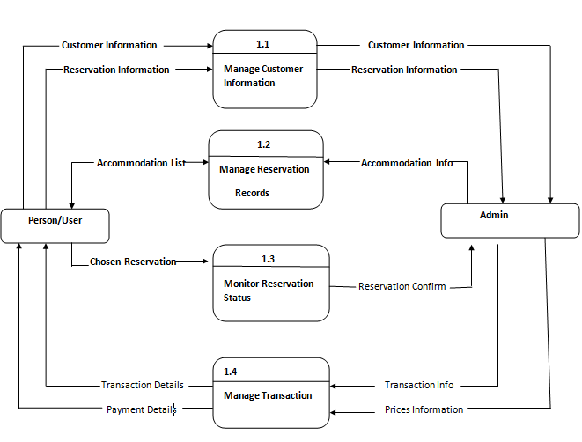

Figure 1: ER diagram of Online Hotel Reservation System

### **3.1.4 Process Modeling**

As information moves through software, it is modified by a series of transformations. A data flow diagram (DFD) is a graphical representation that depicts information flow and the transforms that are applied as data move from input to output. The data flow diagram may be used to represent a system or software at any level of abstraction. In fact, DFDs may be partitioned into levels that represent increasing information flow and functional detail. Therefore, the DFD provides a mechanism for functional modeling as well as information flow modeling. It satisfies the second operational analysis principle. A level 0 DFD, also called a fundamental system model or a context model, represents the entire software element as a single bubble with input and output data indicated by incoming and outgoing arrows, respectively. Additional processes and information flow paths are represented as the level 0 DFD is partitioned to reveal more detail.

Data flow Diagram is a commonly used technique in the System Analysis stage of development. The Data Flow Diagram (DFD) provides the key means of achieving one of the most important requirements of structured development-the notion of structure. The DFD allows the system to be partitioned into development into independent units so that they, and thereby the system, can be more easily understood. The graphical aspect of DFD means that they can be used both as static pieces of documentation and as a communication tool.

The context level data flow diagram is known as Level 0 DFD. It represents the system at a high level of detail in terms of its inputs from external entities and its outputs to external entities. It has one process box for the entire system along with the external entities, data sources and data flows. It represents the system level description of the processes explaining how the system interacts with external entities. It takes input forms and login systems and generate report display as well update database of OHMS.

**CONTEXT LEVEL DFD HOTEL MANAGEMENT SYSTEM**

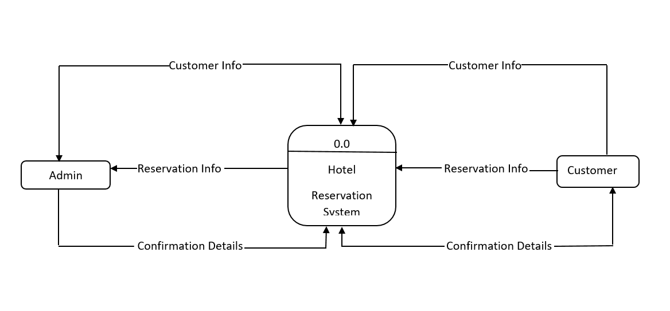 **Figure 2: Level 0 DFD**

#### **3.1.4.1 First level DFD for ADMIN LOGIN**

After entering to the home page of the website, admin can choose the ADMIN LOGIN option where they are asked to enter username & password, and if he/she is a valid user then admin login page will be displayed.

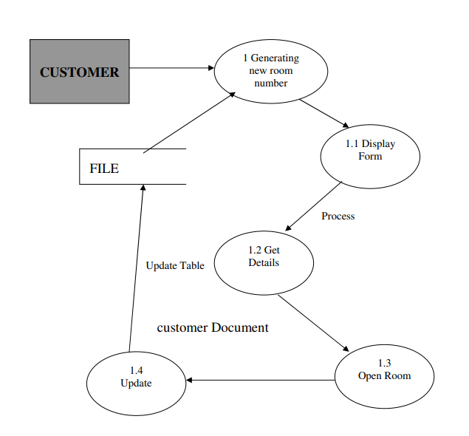

Fig 3: DATA FLOW DIAGRAM OPENING A NEW ROOM

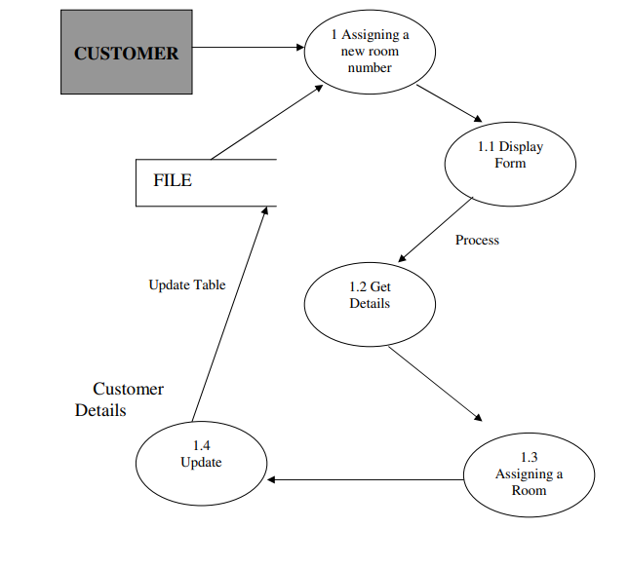

Fig4: DATA FLOW DIAGRAM CHECK-IN OF NEW CUSTOMER

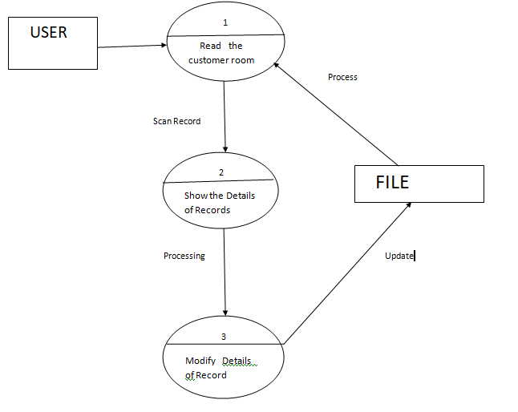 Fig5: DATA FLOW DIAGRAM RECORD MODIFICATION

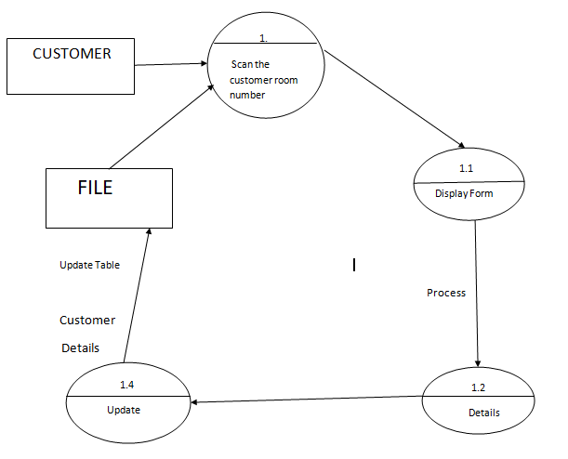

Fig 6: DATA FLOW DIAGRAM CHECK-OUT OF CUSTOMER

**3.2 System Design**

The system is designed using the Model View Controller (MVC) Architecture. MVC is a system architecture that separates application into three main components, namely the model, view and controller, each playing different roles. Model is the main functionality or the domain-specific representation of the information, views are the user interfaces and the controllers are the ones who respond to user actions and invoke appropriate changes on the model and view. The purpose of separating the application is to make sure that the modification to one component will cause the least impact to the others and thus promoting system maintainability. This architecture is especially useful in a system where there exist many types of users with many different levels of authorization. Different styles of display or data are required to facilitate different types of users. No duplicate user interface needed to be created as the model and controller will detect and react according to user role. This is because MVC architecture supports multiple presentations of data and separate styles of interaction with each presentation.

### **3.2.1 Architectural Design**



Fig 10: Architectural Diagram of Online Hotel Reservation system

### **3.2.2 Database Design**

**Database name: Hotel**

**Admin Table:**

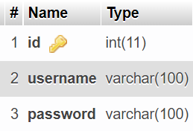

Fig 11: Admin Table

**Create Account Table:**

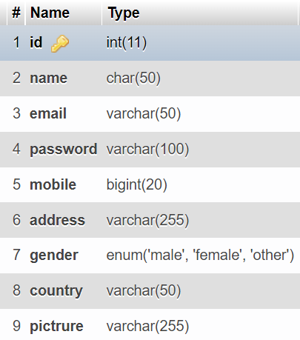

Fig 12: Create Account Table

**Feedback Table:**

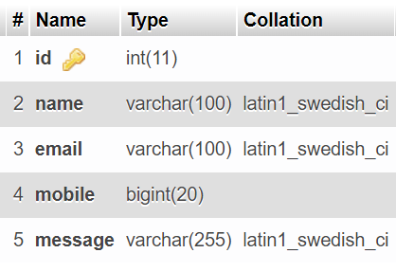

Fig13: Feedback Table

**Rooms Table:**

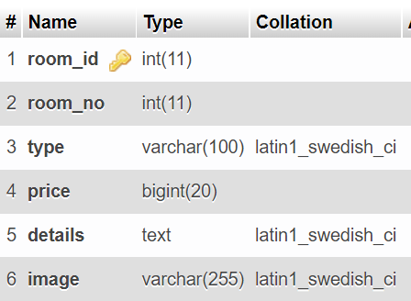

Fig 14: Rooms Table

**Table Slider:**

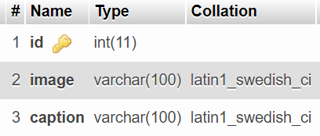

Fig 15: Table Slider

**Room Booking Details Table:**

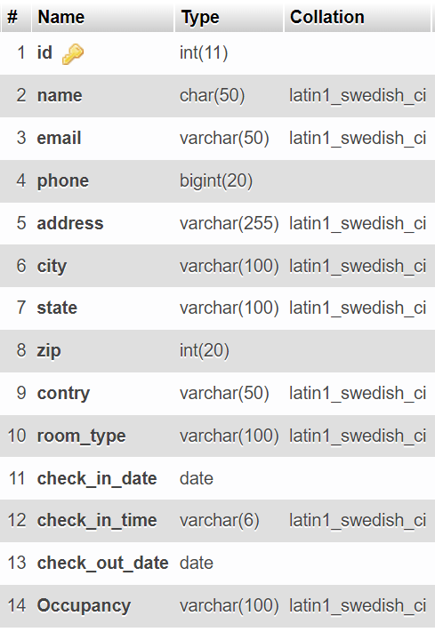

Fig 16: Room Booking Details Table

### 

### **3.2.3 Interface Design**

**Home Page:**

The ONLINE HOTEL RESERVASTION SYSTEM is great project. This project is designed for successful completion of project on hotel management system. The basic building aim is to provide online hotel booking service to the people via internet. Online Hotel Reservation System (OHRS) is a browser based system that is designed to store, process, retrieve and analyze information concerned with the administrative and inventory management within a Hotel. This project aims at maintaining all the information pertaining to users, different rooms available and helps them manage in a better way.

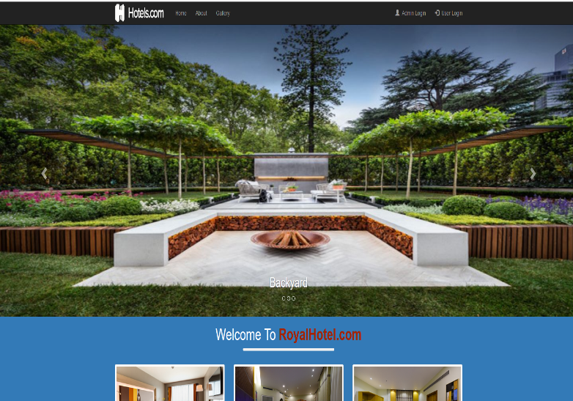

Fig17: Homepage

**Admin:**

The page requires user name and password to start the application. Login is a process by which individual access to a computer system is controlled by identifying and authenticating the user through the cardinalities presented by the user. Admin can add update or delete the user, city, state, camp etc.

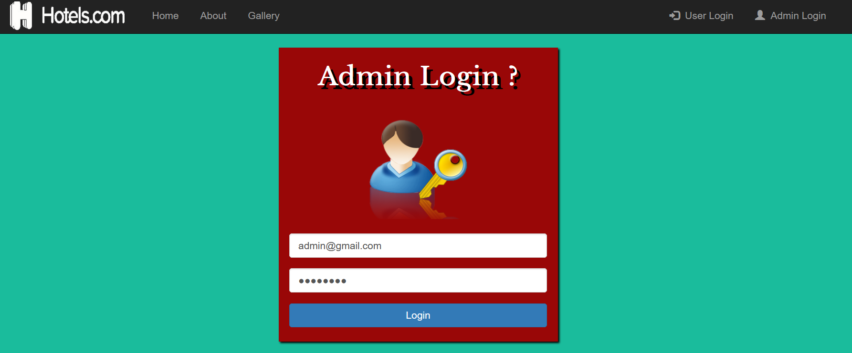

Fig 18: Admin Login

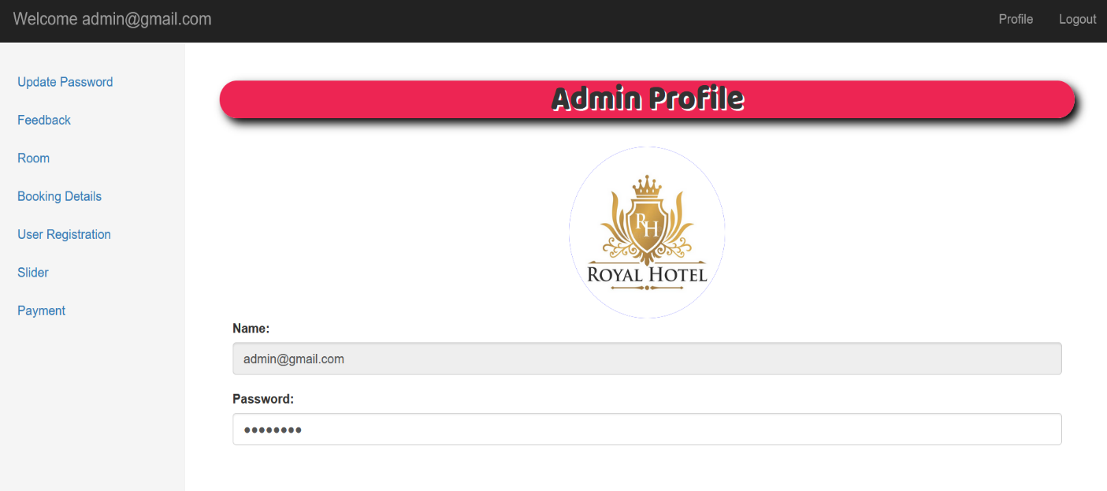

Fig 19: Admin Profile

**User Login:**

User can register the account by fill the information about you and click on save button. He/she can add the account for the further enquiry of the hotel booking. The user have to login to get more information about the hotel and it’s facilities.

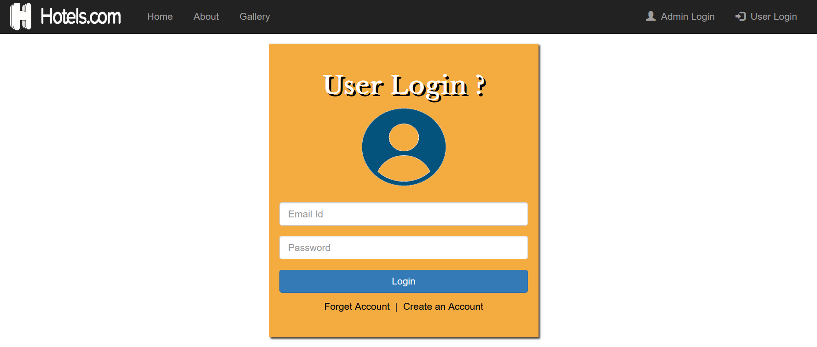

Fig 20: User login

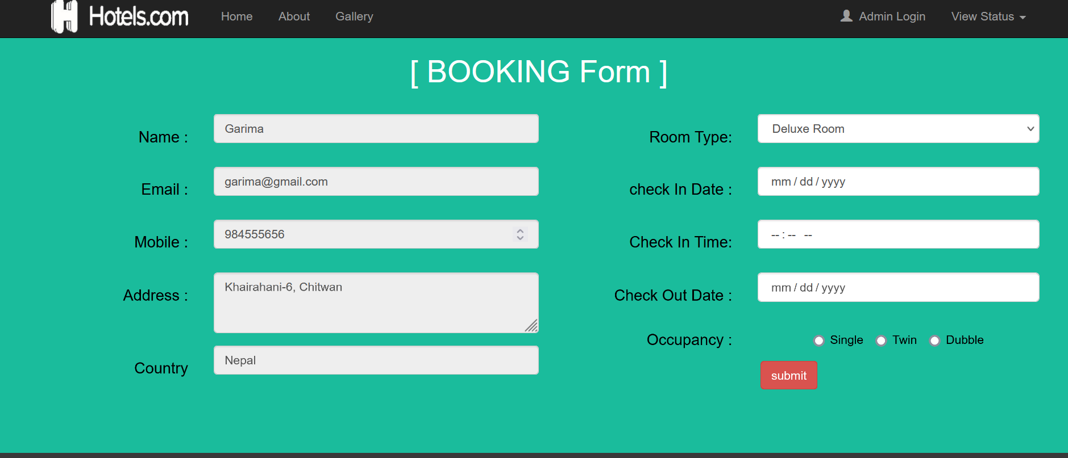

Fig 21: Booking Form

**Registration Form:**

Registration page includes the information of the User who wants to register. User can register the account by clicking on new register. He/she can add the account for the further enquiry of the hotel reservation.

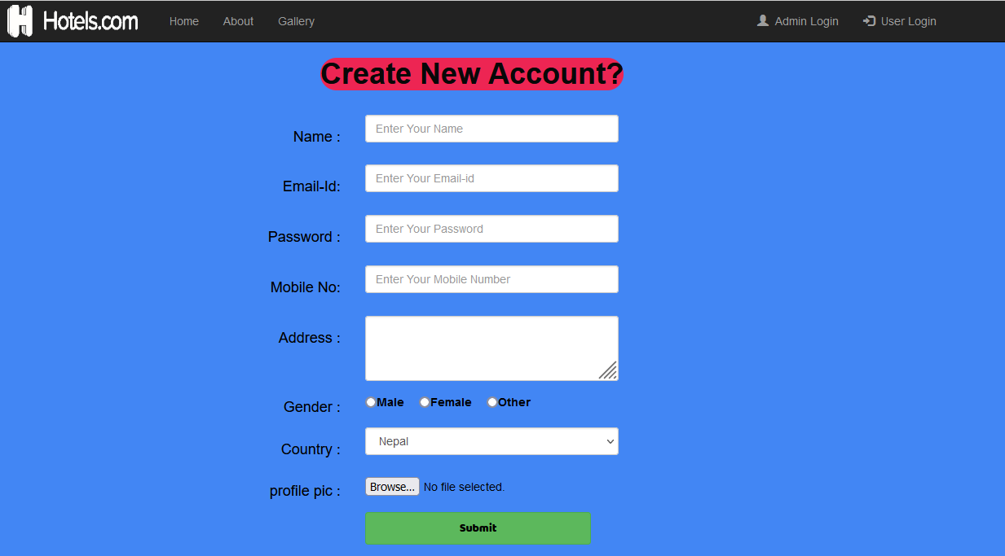

Fig 22: Registration Form

# 

# Chapter 4: Implementation and Testing

## **4.1 Implementation**

During the software implementation phase, each module of software is thoroughly tested for bugs and for accuracy of output. The system developed is very user-friendly and the detailed documentation is also given to the user as online help wherever necessary. The implementation phase normally ends with the formal test involving all the components.

### **4.1.1 Tools Used:**

There are several tools and technologies used for creating this system. Among them these tools and technologies has been chosen:

1. Hardware:

* Server Application
* Client Application

2. Software:

a) Code development:

* HTML
* PHP
* Java script
* MYSQL

3. Documentation:

* Microsoft Word

**Database Platforms:**

**MySQL:** MySQL is the world second most widely used open-source relational database management system (RDBMS). The SQL phrase stands for Structured Query Language. MySQL is used to store all the data of project.

### **4.1.2 Implementation Details of Modules:**

The proposed system is composed of different module such as user module, login module, admin module, delete user module.

**User Module:**

In user module account is created by filling the form detail which includes the field like username, email address, phone number, password, confirm password. User data is stored in the database after filling correct details in the registration form while creating account. After successfully creating an account user can login to the system and can get logout from the system.

**Admin Module:**

In Admin Module authentication is done using email and password given to the admin if admin enters correct email and password then admin can access to dashboard. Admin also can login the system and manage user and can logout from the system.

**Login Module:**

In Login Module user can login to the system after successfully creating an account. Login module consist of two field such as email field and password field. User must enter correct email and password to login into the system.

**Delete User Module:**

In Delete User Module can removed from existing system and this module is performed by admin only. Admin can access all the users present in the database and remove the user from the existing system. Only admin can access this system.

**4.2 Testing:**

A test plan is a document describing the scope, approach, resources, and schedule of intended testing activities. It identifies test items, the features to be tested, the testing OHRS, who will do each OHRS, and any risks requiring contingency planning.

**Table 2: Test report bugs and solutions**

|  |  |  |
| --- | --- | --- |
| **S.N.** | **Bugs:** | **Solution:** |
| **1** | Differential backup generated an execution time error.  **Error description:**  Constraint Violation. | Differential, files and transactsion log backups avoided |
| **2** | Interface command to the enterprise manager was unable to be executed with mere command of shell.  **Error description:**  File Not Executable. | Re-do the whole process of the project starting to end. |
| **3** | Size of files and response details could not be loaded during the display of search contents.  **Error description:**  Process Access Denied. | Permitted attributes displayed. |
| **4** | Unable to detect associated files by itself when called for.  **Error description:**  File Not Found. | Required associations assembled.  Detection remains unsolved. |

# Chapter 5: Conclusion and Future Recommendations

## 

## **5.1 Lesson Learnt/Outcome**

The system was able to attain some of the goals that were set the beginning of development. Below are a few of those goals that were reached:

* The system can adequately keep users record for future reference.
* Making hotel reservation easy and quick via internet.
* Digitalizing Hotel and Tourism Industry.
* The system can generate a list of users with their contact details.
* All the process of submission of registration form is quite simple.
* Department can collect information and desired feedbacks from users for improvement.

## **5.2 Conclusion**

The ultimate goal and aim of the project was to create Online Hotel Reservation System that to provides quick and instant access to hotel. This objective has been met. The application meets all the user requirements and is usable in a local environment such as hotel booking centers to provide a quick access to the hotel as well as management of records.

## **5.3 Future Recommendations**

The greatest challenge of the developer faced understood the requirements which kept on changing. Furthermore, load testing software was difficult to find, the ones that came through are not reliable, and expensive.

For the further recommendations, this software can be converted to mobile apps so that it would be easy for operation from the mobile devices too.

**Appendix A:**

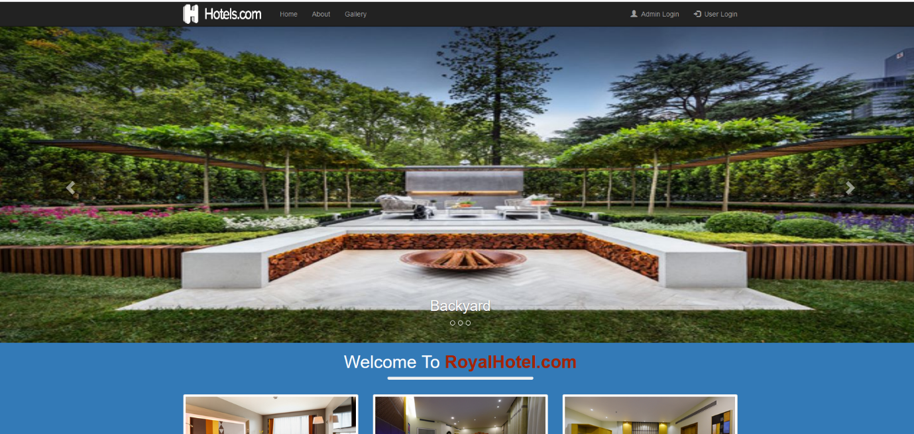

Fig23: Homepage

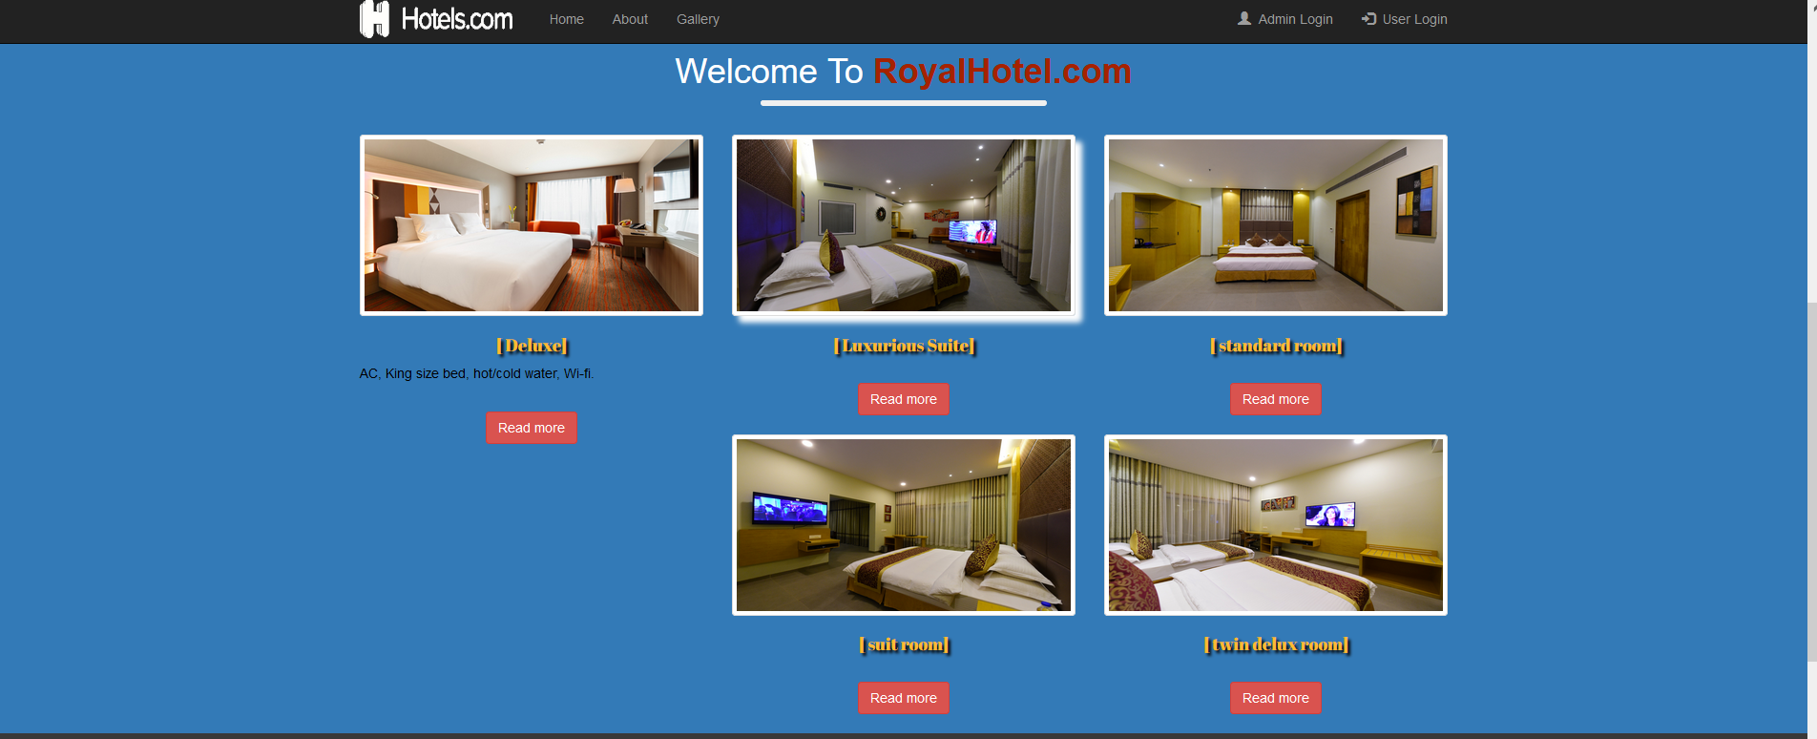

Fig24: Homepage

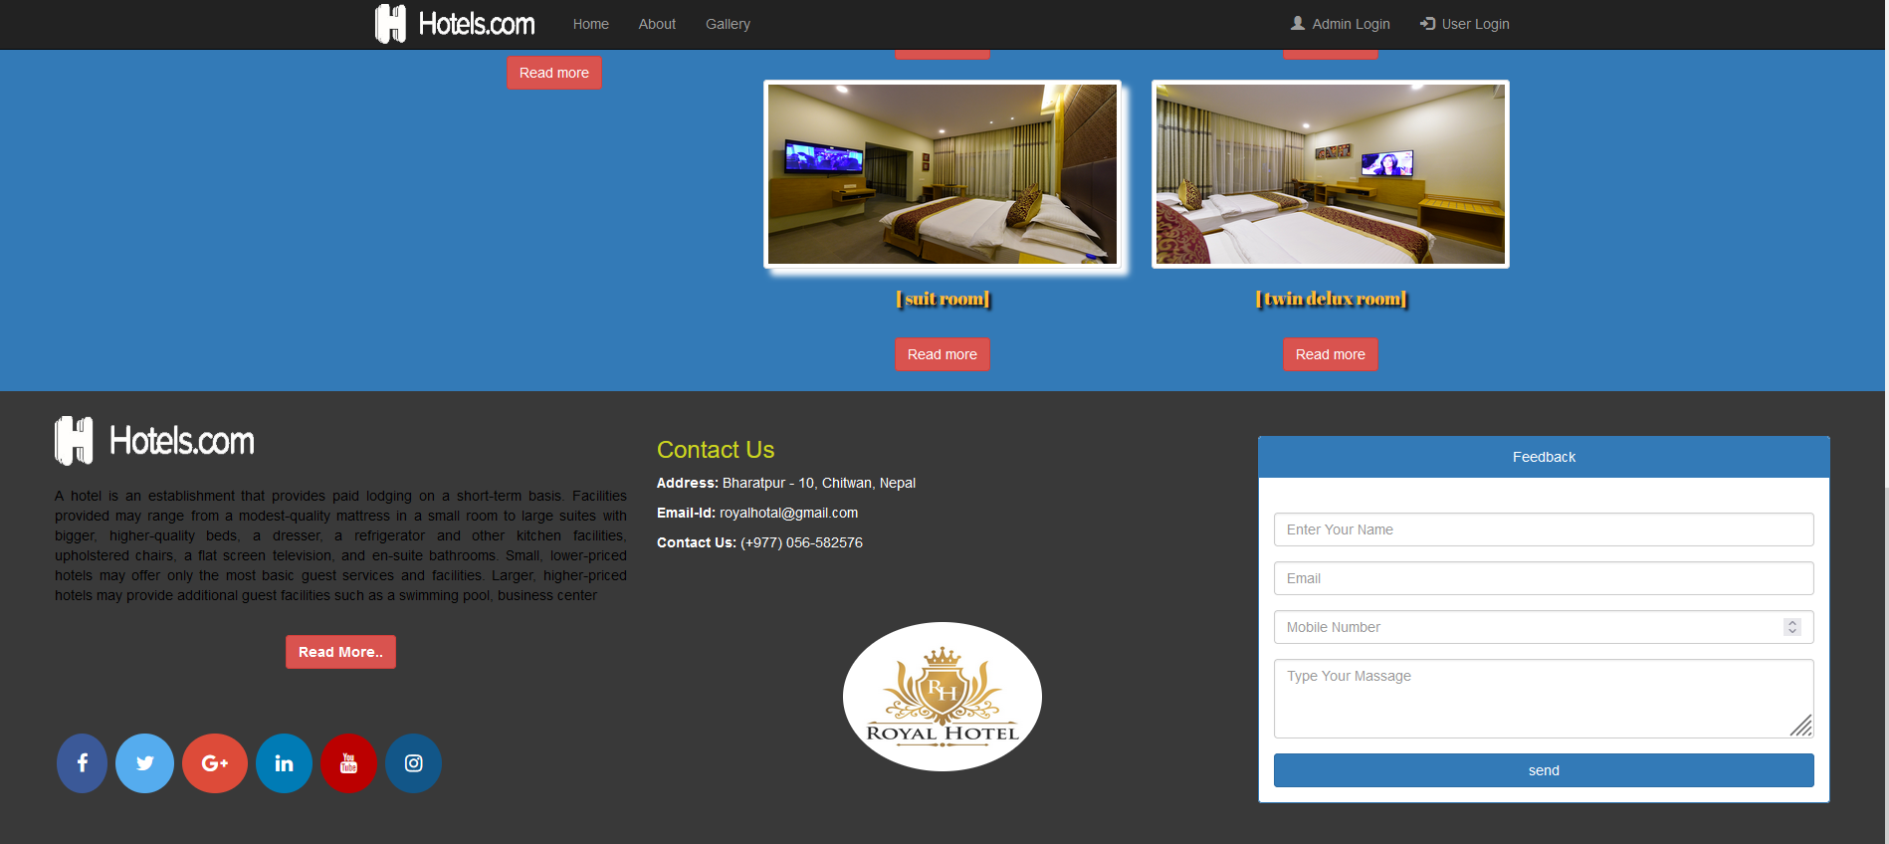

Fig25: Homepage



Fig26: Admin login page

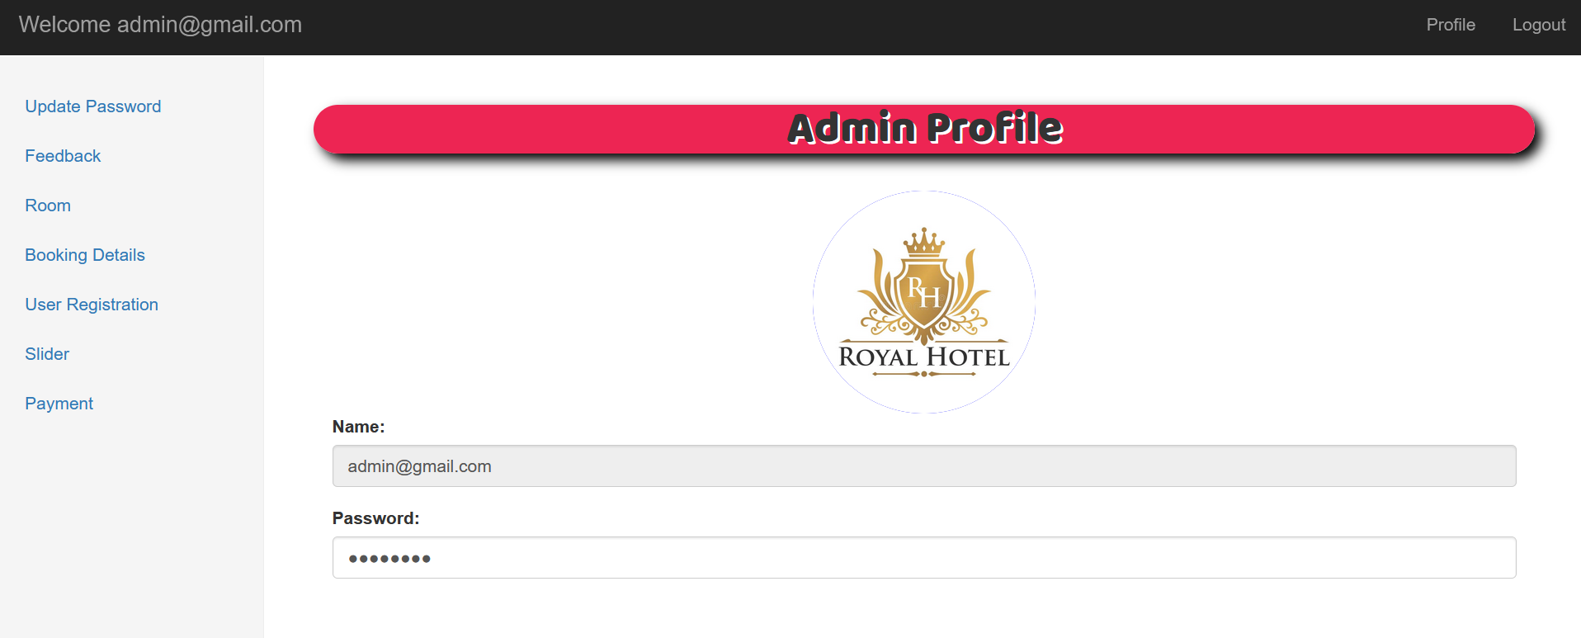

Fig27: Admin login page

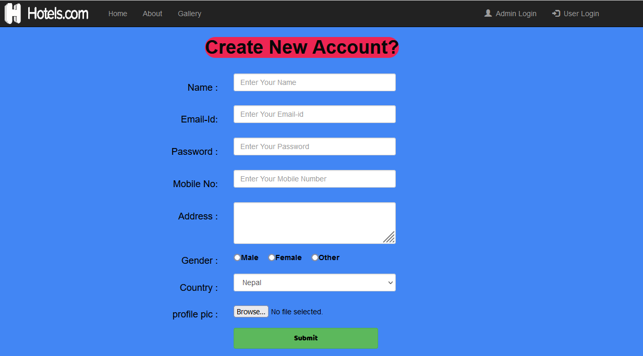

Fig28: Registration page



Fig29: User login page

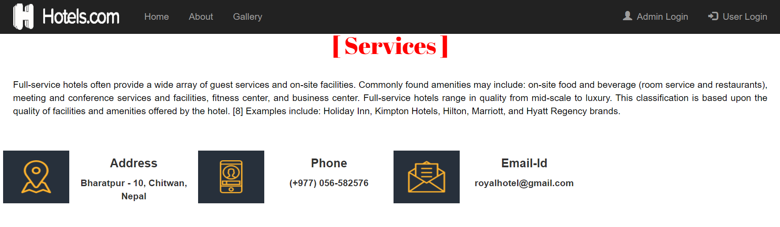

Fig30: Services page

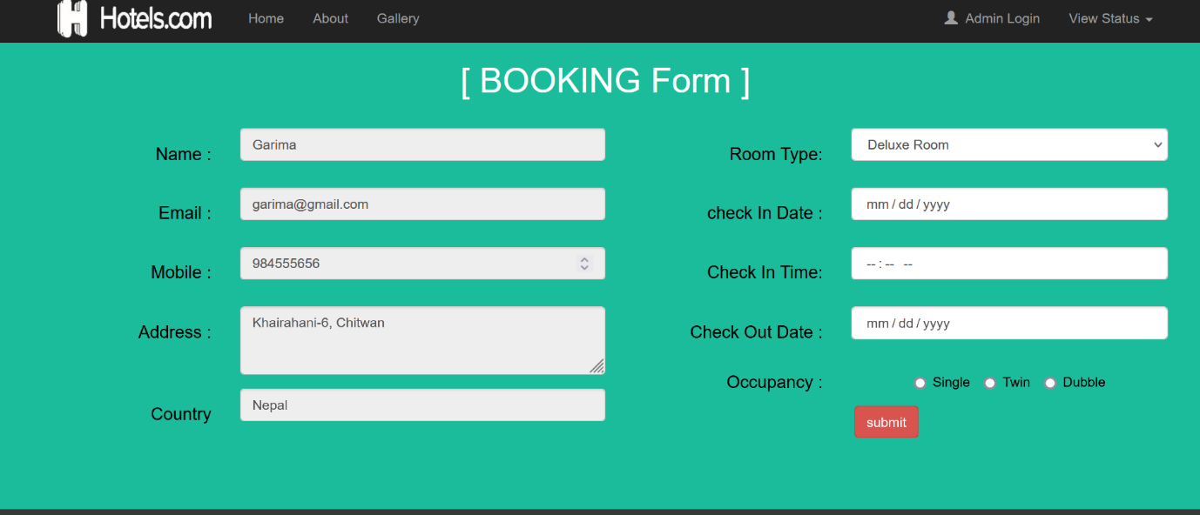

Fig31: Booking form page

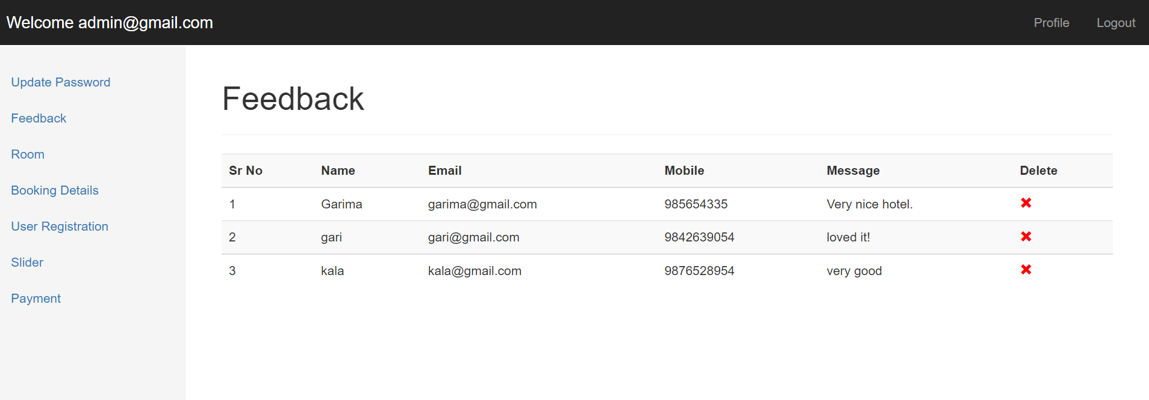

Fig32: Feedback page

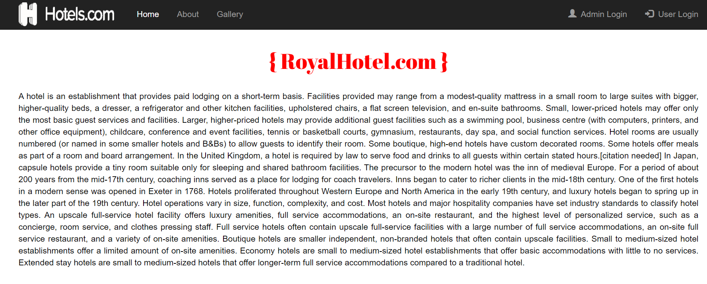

Fig33: About page

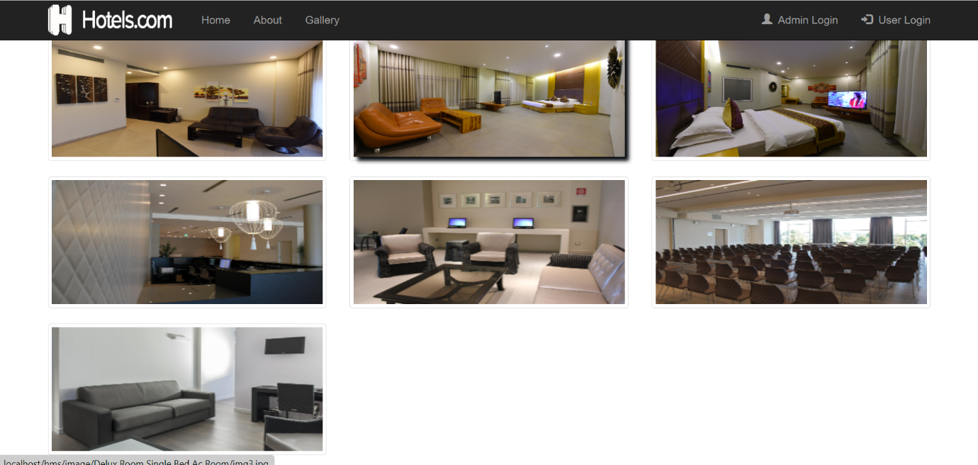

Fig34: Galary page

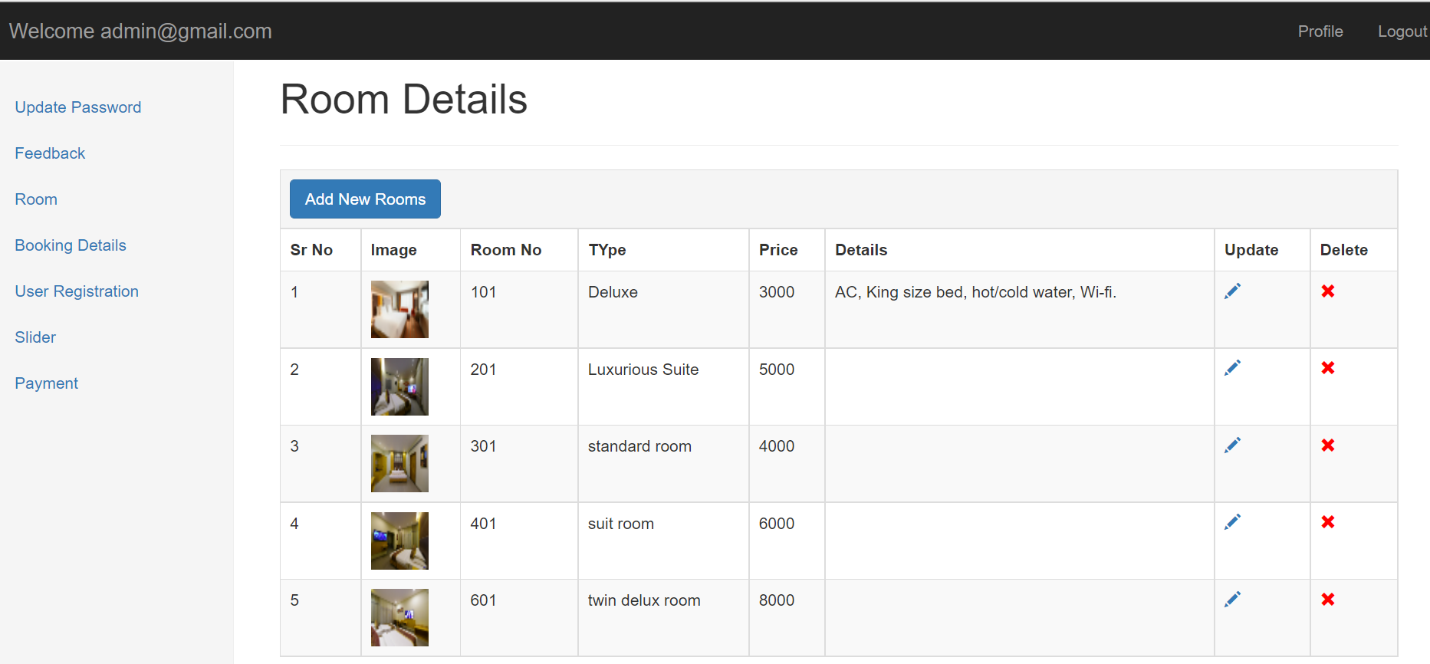

Fig35: Room details page

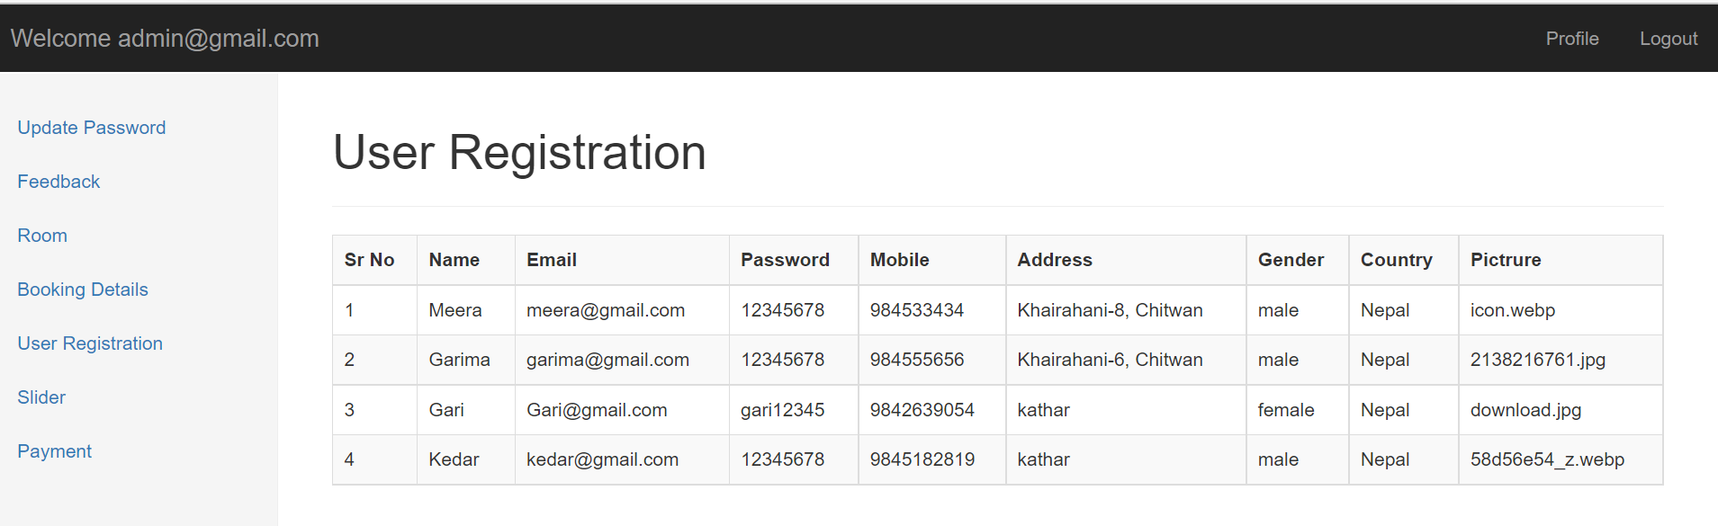

Fig36: Userregistration page

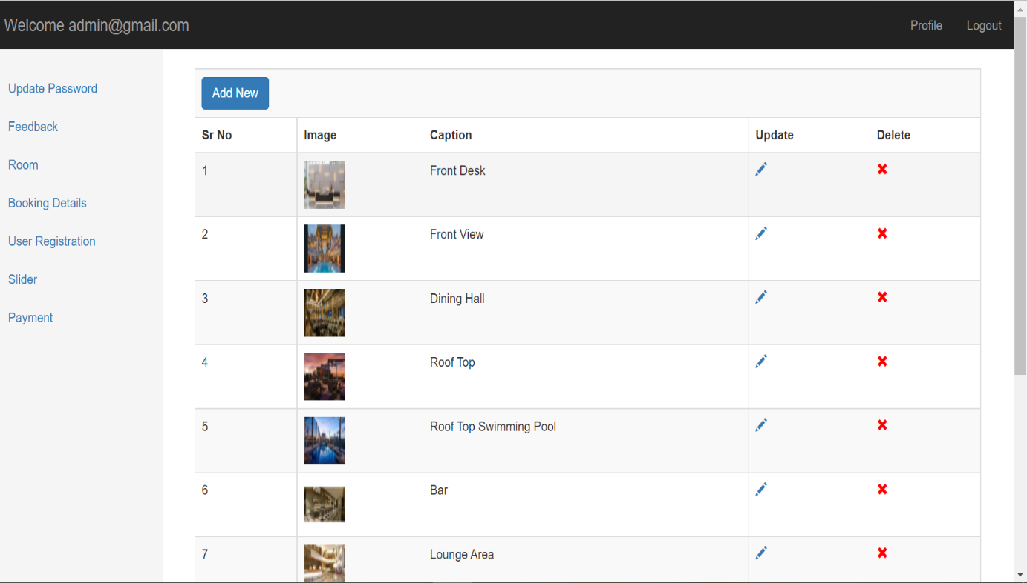

Fig37: Sliderpage

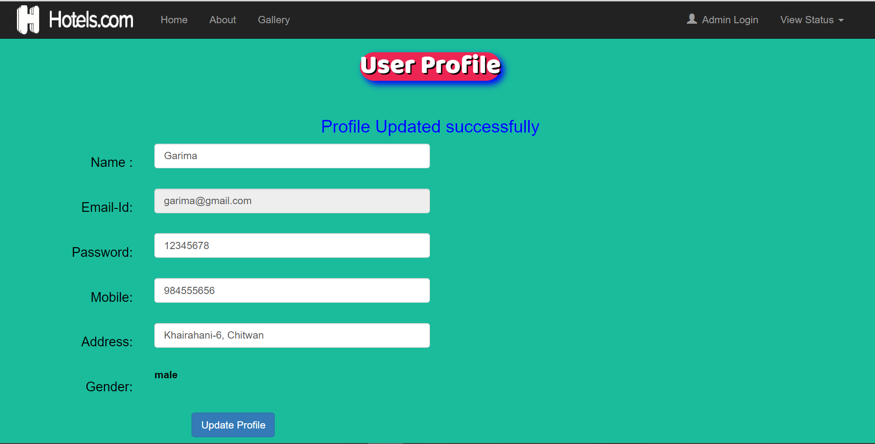

Fig38: User profile page

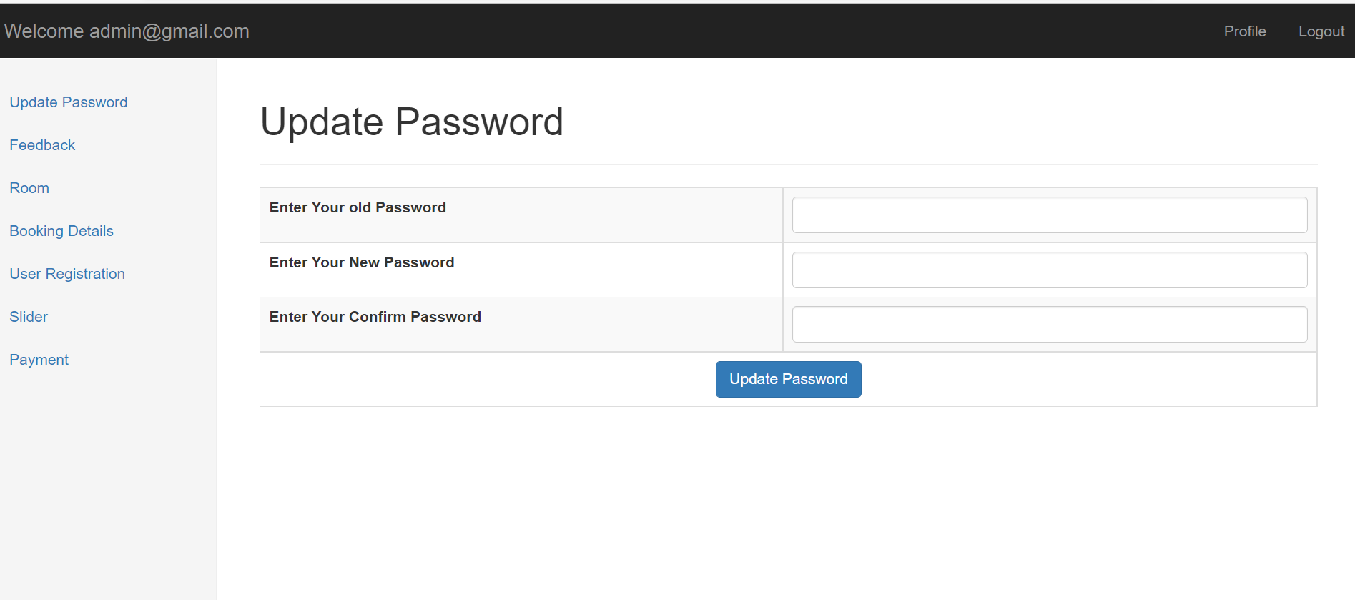

Fig39: Update password page

**Appendix B:**

**Login page:**

<?php

session_start();

error_reporting(1);

if($_SESSION['create_account_logged_in']!="")

{

header('location:Booking Form.php');

}

error_reporting(1);

require('connection.php');

extract($_REQUEST);

if(isset($login))

{

  if($eid=="" || $pass=="")

  {

  $error= "<h4 style='color:red'>fill all details</h4>";

  }

  else

  {

  $sql=mysqli_query($con,"select * from create_account where email='$eid' && password='$pass' ");

    if(mysqli_num_rows($sql))

    {

    $_SESSION['create_account_logged_in']=$eid;

    header('location:Booking Form.php');

    }

    else

    {

    $error= "<h4 style='color:red'>Invalid login details</h4>";

    }

  }

}

?>

<!DOCTYPE html>

<html lang="en">

<head>

  <title>RoyalHotel.com</title>

  <meta charset="utf-8">

  <meta name="viewport" content="width=device-width, initial-scale=1">

  <link rel="stylesheet" href="https://maxcdn.bootstrapcdn.com/bootstrap/3.4.0/css/bootstrap.min.css">

  <script src="https://ajax.googleapis.com/ajax/libs/jquery/3.3.1/jquery.min.js"></script>

  <script src="https://maxcdn.bootstrapcdn.com/bootstrap/3.4.0/js/bootstrap.min.js"></script>

  <link href="css/style.css"rel="stylesheet"/>

  <link rel="stylesheet" href="https://cdnjs.cloudflare.com/ajax/libs/font-awesome/4.7.0/css/font-awesome.min.css">

  <link href="https://fonts.googleapis.com/css?family=Akronim|Libre+Baskerville" rel="stylesheet">

</head>

<body style="margin-top:50px;">

<?php

include('Menu Bar.php')

?>

<div class="container-fluid"><!-- Primary Id-->

  <div class="container">

    <div class="row"><br>

      <div class="col-sm-4"></div>

        <div class="col-sm-4 text-center"style="box-shadow:2px 2px 2px;background-color:#f4ac41;"><br>

          <h1 align="center"><b><font style="font-family: 'Libre Baskerville', serif;text-shadow:3px 3px #000;">User Login ?</font></b></h1>

          <img src="image/clipart/login-user-icon.png" class="img-circle" alt="Bird" width="130" height="120">

          <?php echo @$error; ?>

          <form method="post"><br>

              <div class="form-group">

                <input type="Email" class="form-control"name="eid"placeholder="Email Id" autocomplete="off"required >

              </div>

            <div class="form-group">

                <input type="Password" class="form-control"name="pass"placeholder="Password" autocomplete="off"required>

            </div>

          <input type="submit" value="Login" name="login" class="btn btn-primary btn-group btn-group-justified"required>

          <div class="form-group forget">

                <a href="Forgot account.php">Forget Account</a>&nbsp; <b>|</b>&nbsp;

                <a href="Registation form.php">Create an Account</a>

            </div>

        </form><br>

        </div>

    </div><br>

  </div>

</div>

<?php

include('Footer.php')

?>

</body>

</html>

**Logout page:**

<?php

session_start();

$_SESSION['create_account_logged_in']=$eid;

header('location:index.php');

?>

**Registration Form:**

<?php

include('connection.php');

extract($_REQUEST);

if(isset($save))

{

  $sql= mysqli_query($con,"select * from create_account where email='$email' ");

  if(mysqli_num_rows($sql))

  {

  $msg= "<h1 style='color:red'> account already exists</h1>";

  }

  else

  {

      $sql="insert into create_account(name,email,password,mobile,address,gender,country,pictrure) values('$fname','$email','$Passw','$mobi','$addr','$gend','$countr','$pict')";

   if(mysqli_query($con,$sql))

   {

   $msg= "<h1 style='color:green'>Data Saved Successfully</h1>";

   header('location:Login.php');

   }

  }

}

?>

<!DOCTYPE html>

<html lang="en">

<head>

  <title>RoyalHotel.com</title>

  <meta charset="utf-8">

  <meta name="viewport" content="width=device-width, initial-scale=1">

  <link rel="stylesheet" href="https://maxcdn.bootstrapcdn.com/bootstrap/3.4.0/css/bootstrap.min.css">

  <script src="https://ajax.googleapis.com/ajax/libs/jquery/3.3.1/jquery.min.js"></script>

  <script src="https://maxcdn.bootstrapcdn.com/bootstrap/3.4.0/js/bootstrap.min.js"></script>

  <link href="css/style.css"rel="stylesheet"/>

   <link rel="stylesheet" href="https://cdnjs.cloudflare.com/ajax/libs/font-awesome/4.7.0/css/font-awesome.min.css">

   <link href="https://fonts.googleapis.com/css?family=Baloo+Bhai" rel="stylesheet">

</head>

<body style="margin-top:50px;">

  <?php

include('Menu Bar.php');

  ?>

<div class="container-fluid"style="background-color:#4286f4;color:#000;"> <!-- Primary Id-->

  <div class="container">

    <div class="row">

      <center><h1 style="background-color:#ed2553; border-radius:50px;display:inline-block;"><b><font color="#080808">Create New Account?</font></b></h1></center>

       <center><?php echo @$msg;?></center><br>

      <div class="col-sm-2"></div>

      <div class="col-sm-6 ">

        <form class="form-horizontal"method="post">

          <div class="form-group">

            <div class="control-label col-sm-5"><h4>Name :</h4></div>

          <div class="col-sm-7">

              <input type="text" name="fname" class="form-control"placeholder="Enter Your Name"required>

          </div>

        </div>

        <div class="form-group">

            <div class="control-label col-sm-5"><h4>Email-Id:</h4></div>

          <div class="col-sm-7">

              <input type="text" name="email" class="form-control"placeholder="Enter Your Email-id" autocomplete="off"required>

          </div>

        </div>

        <div class="form-group">

            <div class="control-label col-sm-5"><h4>Password :</h4></div>

          <div class="col-sm-7">

              <input type="password" name="Passw" class="form-control"placeholder="Enter Your Password"autocomplete="off"required>

          </div>

        </div>

        <div class="form-group">

            <div class="control-label col-sm-5"><h4>Mobile No:</h4></div>

          <div class="col-sm-7">

              <input type="text" name="mobi" class="form-control"placeholder="Enter Your Mobile Number"required>

          </div>

        </div>

        <div class="form-group">

            <div class="control-label col-sm-5"><h4>Address :</h4></div>

          <div class="col-sm-7">

              <textarea  name="addr" class="form-control"required></textarea>

          </div>

        </div>

        <div class="form-group">

            <div class="control-label col-sm-5"><h4 id="top">Gender :</h4></div>

          <div class="col-sm-7">

              <input type="radio" name="gend"value="male"required><b>Male</b>&emsp;

              <input type="radio" name="gend"value="Female"required><b>Female</b>&emsp;

              <input type="radio" name="gend"value="Other"required><b>Other</b>

          </div>

          </div>

          <div class="form-group">

            <div class="control-label col-sm-5"><h4>Country :</h4></div>

          <div class="col-sm-7">

            <select name="countr" class="form-control"required>

              <option> Nepal </Option>

              <option>India</option>

              <option>Pakistan</option>

              <option>China</option>

            </select>

        </div>

        </div>

        <div class="form-group">

            <div class="control-label col-sm-5"><h4 id="top">profile pic :</h4></div>

          <div class="col-sm-7">

              <input type="file" name="pict"accept="image/*"required>

          </div>

          <div class="row">

            <div class="col-sm-6"style="text-align:right;"><br>

            <input type="submit" value="Submit" name="save"class="btn btn-success btn-group-justified"required style="color:#000;font-family: 'Baloo Bhai', cursive;height:40px;"/>

          </div>

          </div>

          </div>

        </form>

        </div>

      </div>

        <div class="col-sm-4">

        </div>

    </div>

  </div>

</div>

<?php

    include('Footer.php')

?>

</body>

</html>

**Bibliography**

* [(5) HOTEL MANAGEMENT INFORMATION SYSTEM PROJECT FINAL | Gideon Babatunde - Academia.edu](https://www.academia.edu/37649550/HOTEL_MANAGEMENT_INFORMATION_SYSTEM_PROJECT_FINAL)
* [A Project Report On Hotel Management System | PDF | Hotel | Restaurants (scribd.com)](https://www.scribd.com/doc/26299255/A-Project-Report-on-Hotel-Management-System)
* [Hotel Management System Project Report % (itsourcecode.com)](https://itsourcecode.com/fyp/hotel-management-system-project-report-documentation-pdf/)
* [Project Report Online Hotel Management System - projectseminar (google.com)](https://sites.google.com/site/freeprojectseminar/project-reports/project-report-online-hotel-management-system)
* Bardi J.A (2011). Wiley: Hotel Office Management 5th Edition (online).
* [Hotel - Wikipedia](https://en.wikipedia.org/wiki/Hotel)